CSC222 MARKING GUIDE
QUESTION ONE
Hamming code is a error-correcting code used in digital communications. It detects and corrects errors that may occur during data transmission. It was introduced by Richard Hamming in the 1940s and is widely used today.The fundamental concept behind Hamming code is adding redundant bits to the original data bits. This can further be used to detect and correct errors during transmission. The number of redundant bits added depends on the size of the data being transmitted and the level of error correction required
Need for Hamming Code in Computer Networks
Hamming Code plays a crucial role in computer networks for ensuring data integrity and reliability in data transmission. Here's why it's essential:
Error Detection and Correction: Hamming Code enables the detection and correction of errors that may occur during data transmission. In network communication, data can get corrupted due to various factors such as electrical noise, interference, or hardware failures. Hamming Code detects errors and, in many cases, corrects them without the need for retransmission, improving the overall reliability of the network.
Efficient Data Transmission: In networks, especially in wireless communication and noisy environments, errors are inevitable. Hamming Code allows for efficient data transmission by providing a mechanism to detect and correct errors at the receiver end without the need for retransmission, thus minimizing the impact of errors on network performance and throughput.
Reduced Latency: Retransmitting data packets due to errors can introduce latency and reduce the overall efficiency of the network. By using Hamming Code for error detection and correction, networks can minimize the need for retransmissions, leading to reduced latency and improved response times for network applications.
Data Integrity: Ensuring data integrity is crucial in computer networks, especially in critical applications such as financial transactions, healthcare systems, and military communications. Hamming Code helps maintain data integrity by detecting and correcting errors, thereby preventing data corruption and ensuring that transmitted data remains accurate and reliable. [3MARKS] ANY TWO .

Coding for compressing data: reducing (on average) the length of the messages. This means trying to remove as much redundancy in the messages as possible.

2. Coding for ensuring the quality of transmission in noisy conditions.

This requires adding redundancy in order to be able to correct messages in the presence of noise.

3. Coding for secrecy: making the message impossible (or hard) to read for unauthorized readers. This requires making access to the information content of the message hard. [3MARKS]

QUESTION TWO
2.3.2 Unicast routing

Most of the traffic on the internet and intranets knew as unicast data or unicast traffic is sent with the specified destination. Routing unicast data over the internet is called unicast routing. It is the simplest form of routing because the destination is already known. Hence the router just has to look up the routing table and forward the packet to next hop.
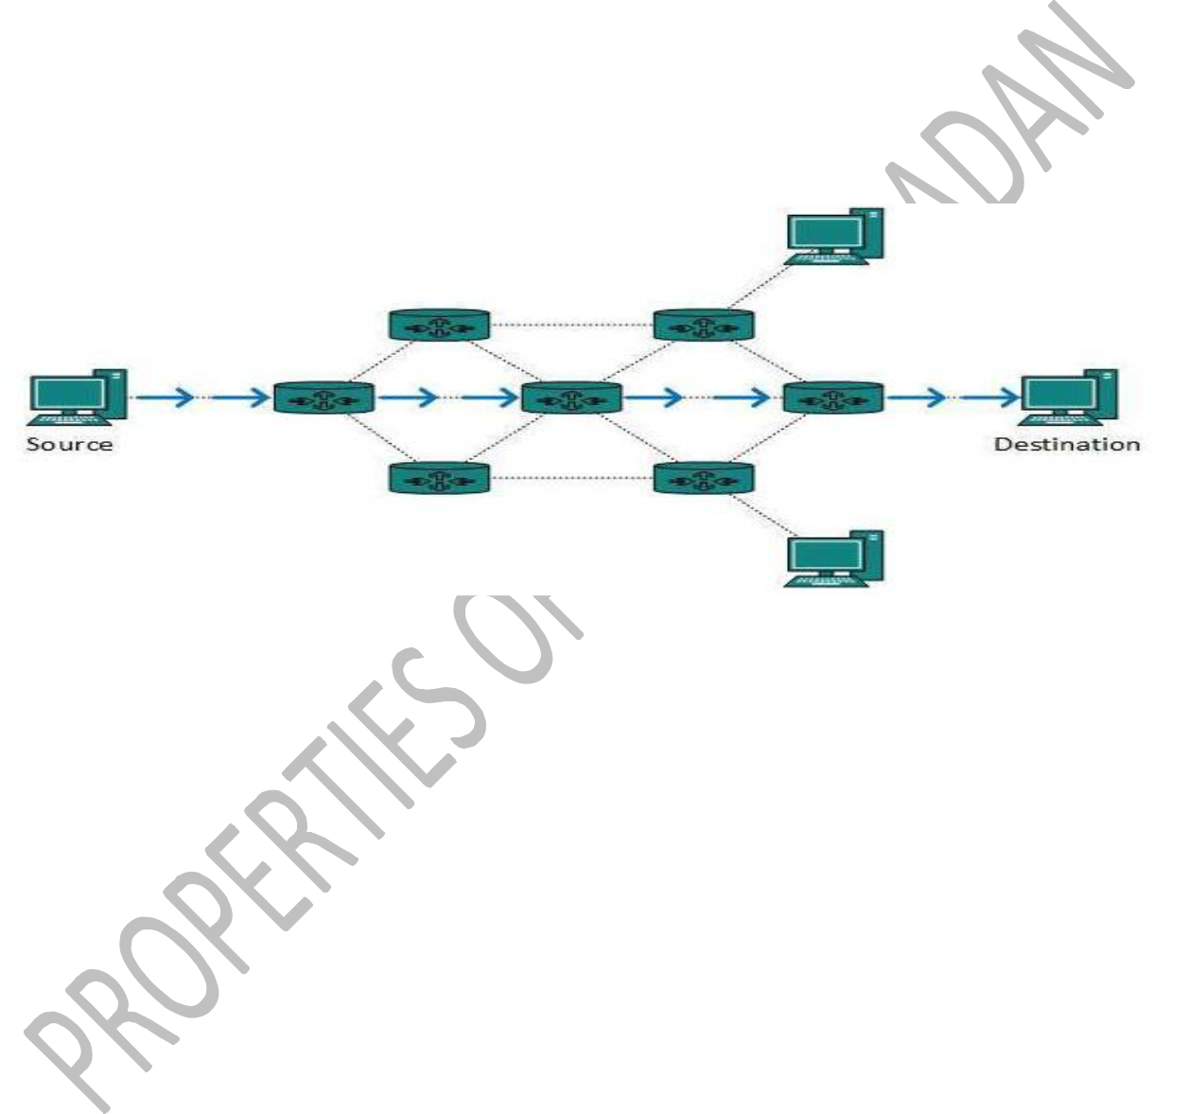

12.3.3 Broadcast routing

By default, the broadcast packets are not routed and forwarded by the routers on any network. Routers create broadcast domains. But it can be configured to forward broadcasts in some special cases. A broadcast message is destined for all network devices.

12.3.3.1 Broadcast routing can be done in two ways (algorithm):

A router creates a data packet and then sends it to each host one by one. In this case, the router creates multiple copies of the single data packet with different destination addresses. All packets are sent as unicast but because they are sent to all, it simulates as if the router is broadcasting.

This method consumes lots of bandwidth and router must destination address of each node.

161

Secondly, when the router receives a packet that is to be broadcasted, it simply floods those packets out of all interfaces. All routers are configured in the same way.

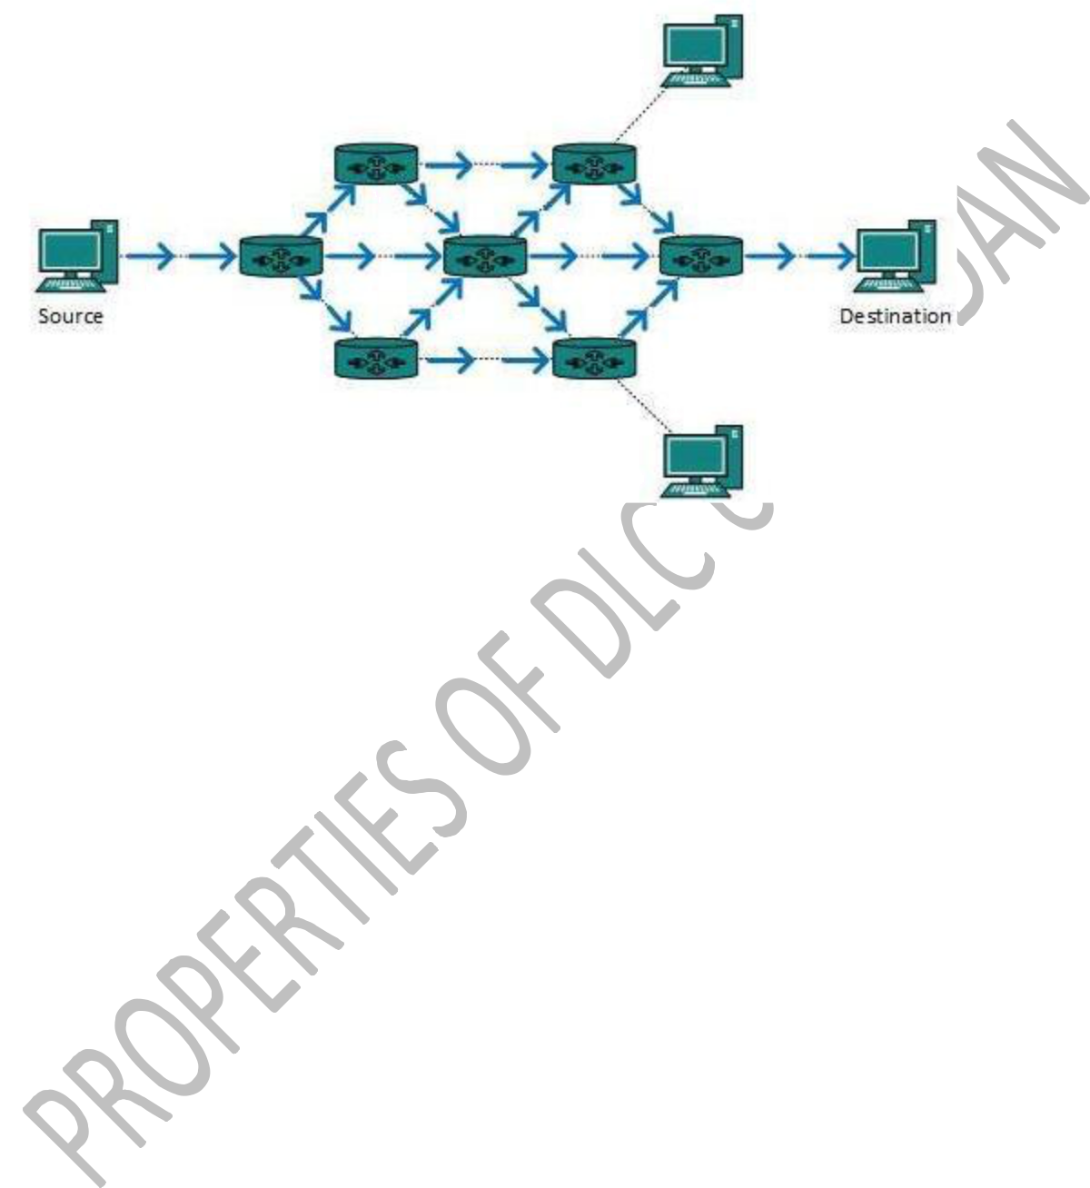

This method is easy on router's CPU but may cause the problem of duplicate packets received from peer routers.

Reverse path forwarding is a technique, in which router knows in advance about its predecessor from where it should receive the broadcast. This technique is used to detect and discard duplicates.

12.3.4 Multicast Routing

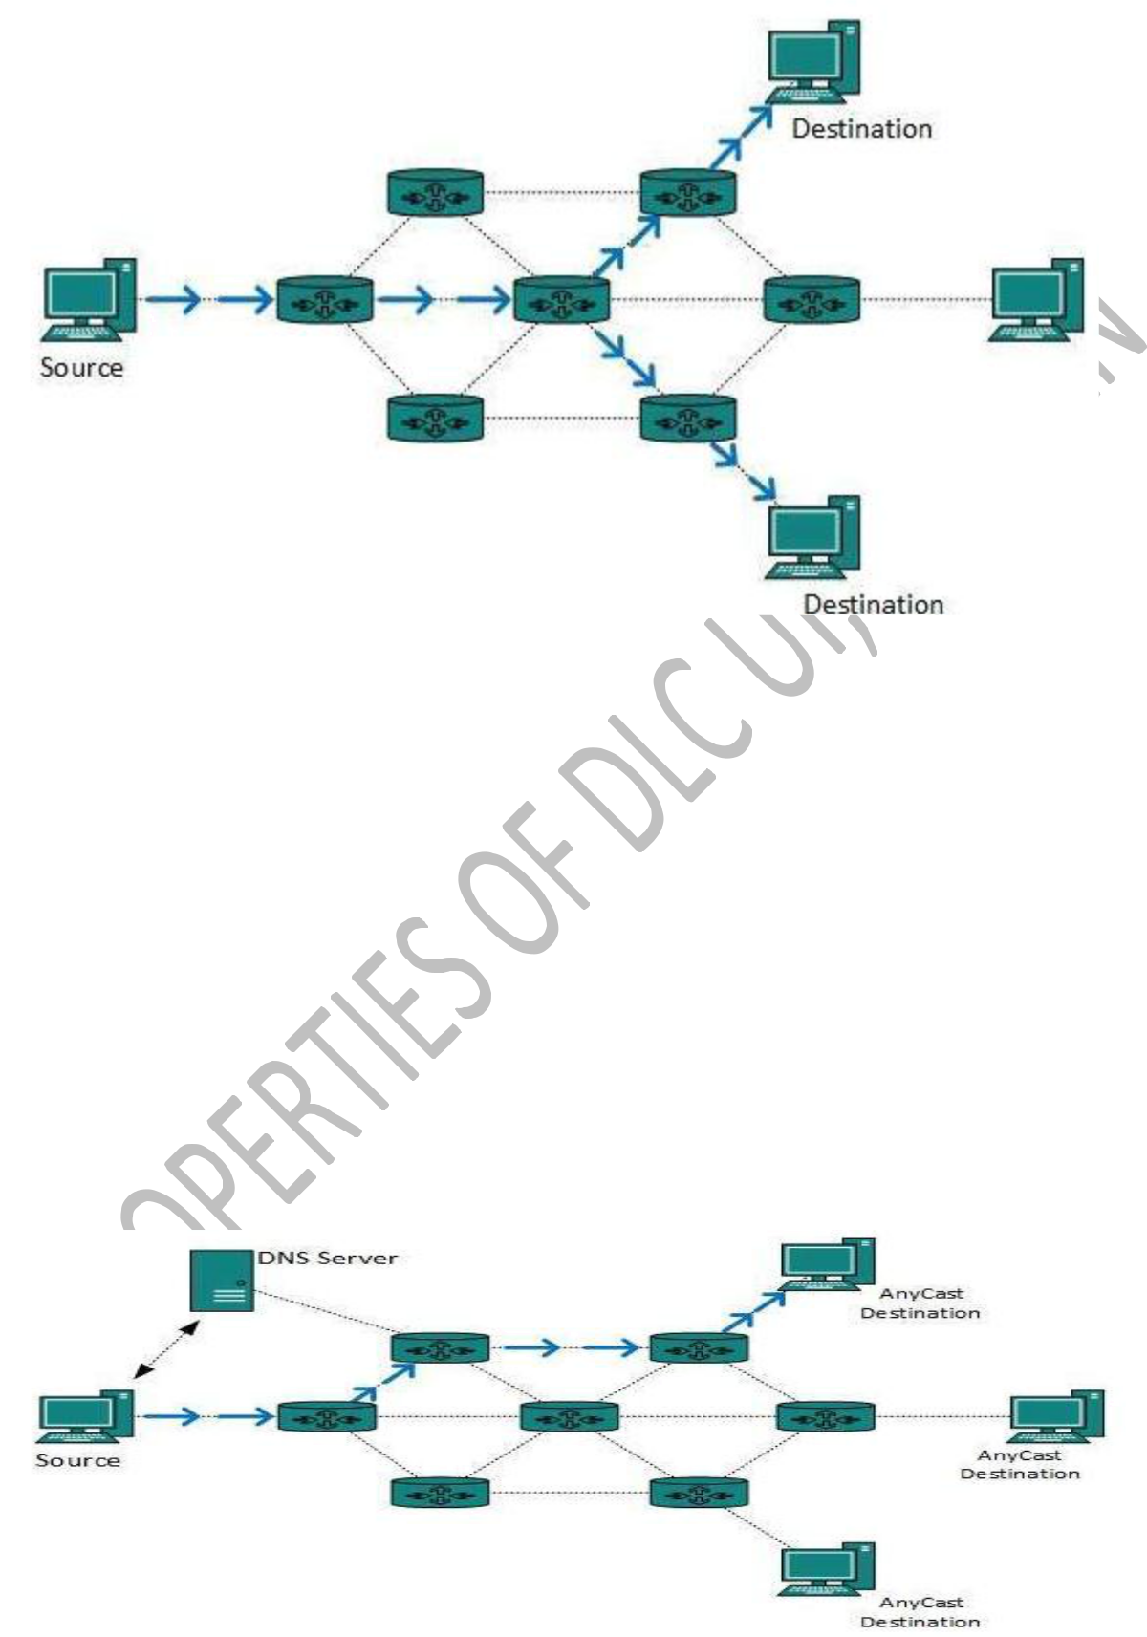
Multicast routing is a special case of broadcast routing with significance difference and challenges. In broadcast routing, packets are sent to all nodes even if they do not want it. But in Multicast routing, the data is sent to only nodes which want to receive the packets.

The router must know that there are nodes, which wish to receive multicast packets (or stream) then only it should forward. Multicast routing works spanning tree protocol to avoid looping.

Multicast routing also uses reverse path Forwarding technique, to detect and discard duplicates and loops.

12.3.5 Anycast Routing
Anycast packet forwarding is a mechanism where multiple hosts can have a same logical address. When a packet destined to this logical address is received, it is sent to the host which is nearest in routing topology. Anycast routing is done with help of DNS server. Whenever an Anycast packet is received it is enquired with DNS to where to send it. DNS provides the IP address which is the nearest IP configured on it
QUESTION THREE
10.4 Aloha

ALOHAnet, also known as the ALOHA System, or simply ALOHA, was a pioneering computer networking system developed at the University of Hawaii. ALOHAnet became operational in June 1971, providing the first public demonstration of a wireless packet data network. ALOHA originally stood for Additive Links On-line Hawaii Area. The ALOHAnet used a new method of medium access (ALOHA random access) and experimental ultra-high frequency (UHF) for its operation since frequency assignments for communications to and from a computer were not available for commercial applications in the 1970s. But even before such frequencies were assigned there were two other media available for the application of an ALOHA channel –

128

cables & satellites. In the 1970s ALOHA, random access was employed in the nascent Ethernet cable-based network and then in the Marisat (now Inmarsat) satellite network.
In the early 1980s frequencies for mobile networks became available, and in 1985 frequencies suitable for what became known as Wi-Fi was allocated in the US. These regulatory developments made it possible to use the ALOHA random-access techniques in both Wi-Fi and in mobile telephone networks. ALOHA channels were used in a limited way in the 1980s in 1G mobile phones for signaling and control purposes. In the late 1980s, the European standardization group GSM who worked on the Pan-European Digital mobile communication system GSM greatly expanded the use of ALOHA channels for access to radio channels in mobile telephony. In addition, SMS message texting was implemented in 2G mobile phones.
Wireless networks.

The most common example of a shared communication medium today, and one that is only increasing in popularity, uses radio. Examples include cellular wireless networks (including standards like EDGE, 3G, and 4G), wireless LANs (such as 802.11, the WiFi standard), and various other forms of radio-based communication. Another example of a communication medium with similar properties is the acoustic channel explored in the 6.02 labs. Broadcast is an inherent property of radio and acoustic communication, especially with so-called omni-directional antennas, which radiate energy in all (or many) different directions. However, radio and acoustic broadcasts are not perfect because of interference and the presence of obstacles on certain paths, so different nodes may correctly receive different parts of any given transmission. This reception is probabilistic and the underlying random processes that generate bit errors are hard to model.
Shared bus networks.

An example of a wired shared medium is Ethernet, which when it was first developed (and for many years after) used a shared cable to which multiple nodes could be connected. Any packet sent over the Ethernet could be heard by all stations connected physically to the network, forming a perfect shared broadcast medium. If two or more nodes send packets that overlap in time, both packets ended up being garbled and received in error.
What is Noise?

Noise is an unwanted signal, which interferes with the original message signal and corrupts the parameters of the message signal. This alteration in the communication process, leads to the message getting altered. It most likely enters at the channel or the receiver. The noise signal can be understood by taking a look at the following figure.

Hence, it is understood that the noise is some signal which has no pattern and no constant frequency or amplitude. It is quite random and unpredictable. Measures are usually taken to

45

reduce it, though it can’t be completely eliminated. Most common examples of noise are :

- Hiss sound in radio receivers

- Buzz sound amidst of telephone conversations

- Flicker in television receivers, etc


4.1.1 Types of Noise

The classification of noise is done depending on the type of the source, the effect it shows or the relation it has with the receiver, etc. There are two main ways in which noise is produced. One is through some external source while the other is created by an internal source, within the receiver section.

4.1.2 External Source

This noise is produced by the external sources, which may occur in the medium or channel of communication usually. This noise cannot be completely eliminated. The best way is to avoid the noise from affecting the signal. Most common examples of this type of noise are:

- Atmospheric noise (due to irregularities in the atmosphere).

- Extra-terrestrial noise, such as solar noise and cosmic noise.

- Industrial noise.

4.1.3 Internal Source

This noise is produced by the receiver components while functioning. The components in the circuits, due to continuous functioning, may produce few types of noise. This noise is quantifiable. A proper receiver design may lower the effect of this internal noise. Most common examples of this type of noise are:

- Thermal agitation noise (Johnson noise or Electrical noise)

- Shot noise (due to the random movement of electrons and holes)

- Transit-time noise (during transition)

46

4.1.4 Miscellaneous noise is another type of noise which includes flicker, resistance effect and mixer generated noise, etc.

4.1.5 Effects of Noise

Noise is an inconvenient feature, which affects the system performance. Following are the effects of noise.

Noise limits the operating range of the systems
Noise indirectly places a limit on the weakest signal that can be amplified by an amplifier. The oscillator in the mixer circuit may limit its frequency because of noise. A system’s operation depends on the operation of its circuits. Noise limits the smallest signal that a receiver is capable of processing
Noise affects the sensitivity of receivers
Sensitivity is the minimum amount of input signal necessary to obtain the specified quality output. Noise affects the sensitivity of a receiver system, which eventually affects the output.
Signal to Noise Ratio
Calculate Signal to Noise Ratios and Figure of Merits of various modulated waves, which are demodulated at the receiver. Signal-to-Noise Ratio (SNR) is the ratio of the signal power to noise power. The higher the value of SNR, the greater will be the quality of the received output. Signal-to-Noise Ratio at different points can be calculated using the following formulas.

Figure of Merit
The ratio of output SNR and input SNR can be termed as Figure of Merit. It is denoted by F. It describes the performance of a device.
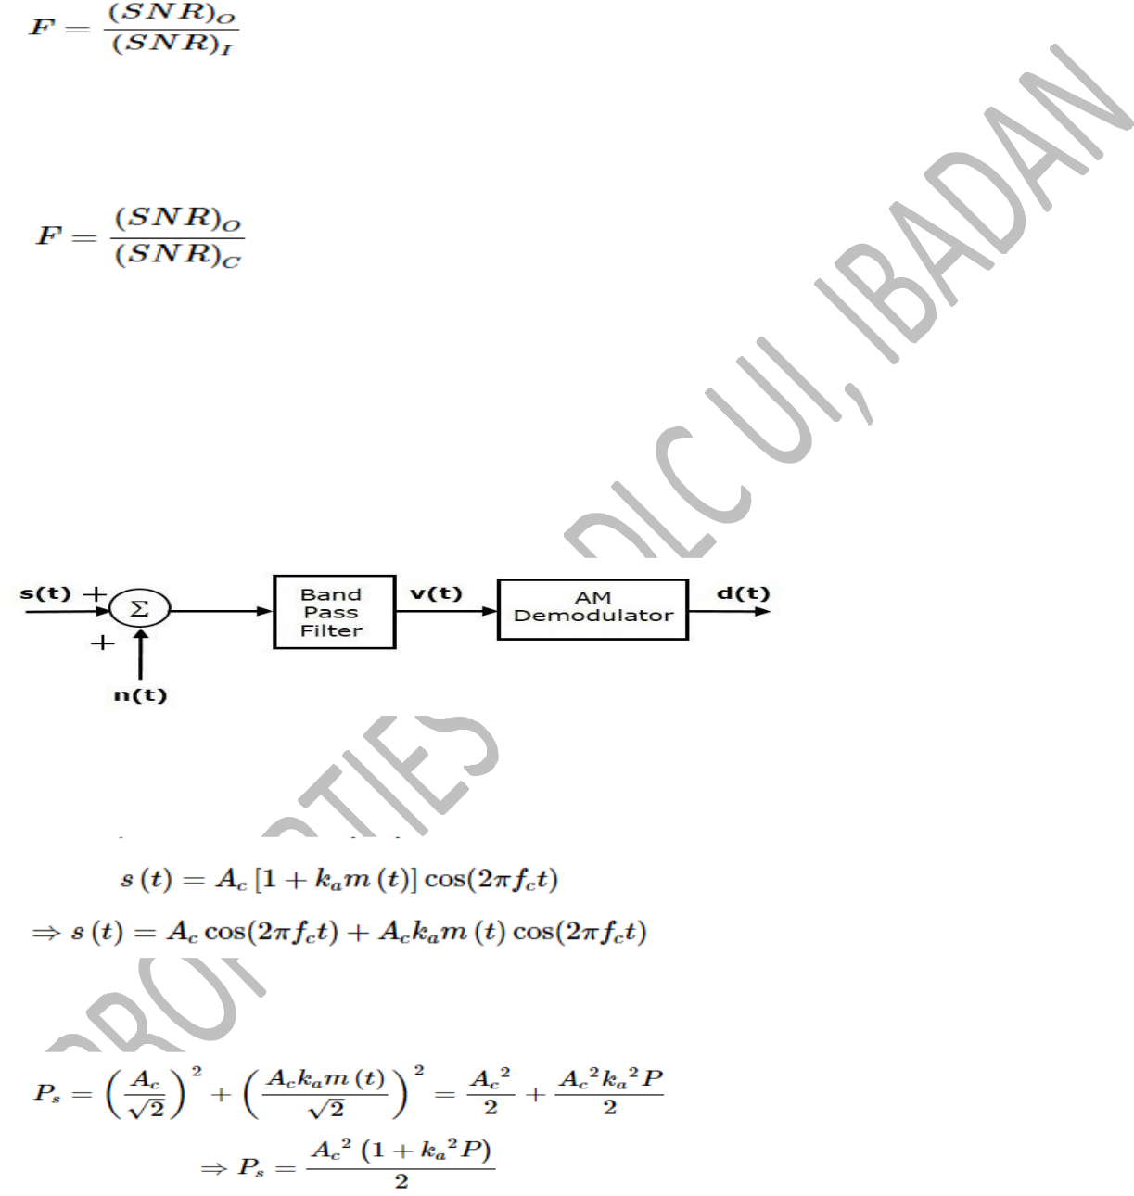

Figure of merit of a receiver is

It is so because for a receiver, the channel is the input

[15marks]

